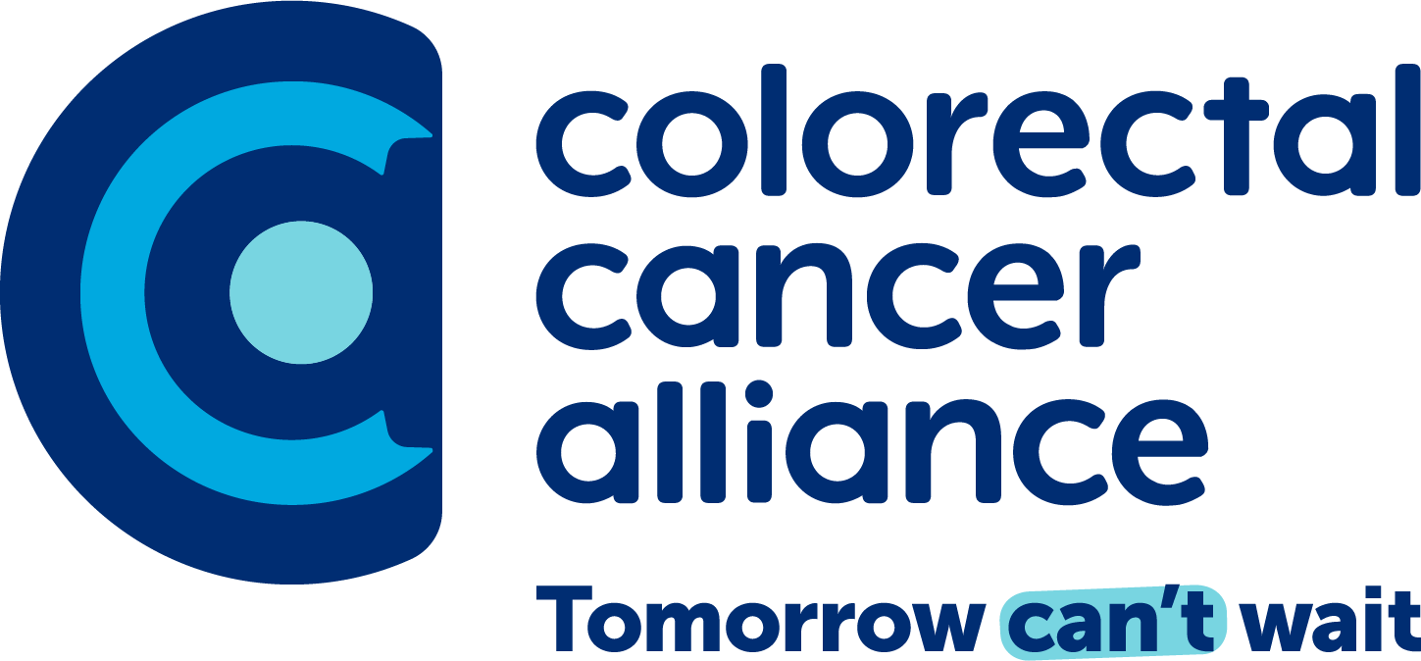

Talking Points / Key Messaging

On Colorectal Cancer:

- Colorectal cancer, or CRC, refers to colon cancer and rectal cancer.
- CRC is the second deadliest and fourth most common cancer in the U.S.
- More than 150,000 people are diagnosed with CRC and more than 50,000 die from the disease each year.
- The average lifetime risk of colorectal cancer is 1 in 24.
- Most people are diagnosed with CRC after age 50, but the rate of young-onset CRC, affecting younger people, is rising.
- Non-Hispanic Black people have the second highest mortality rate and second-highest incidence rate of CRC in the U.S. American Indian and Alaskan Native communities face the highest mortality and incidence rates.
- Colorectal cancer often develops without symptoms. When present, symptoms may include:
  - Blood in or on stool
  - Persistent unusual bowel movements like constipation or diarrhea
  - Stomach pain, aches, or cramps that don’t go away
  - Losing weight for no reason
- Colorectal cancer starts as an abnormal tissue growth, which is called a polyp, inside the colon or rectum. With the help of screening tests, doctors can find polyps and remove them, which prevents colorectal cancer from developing.
- Colorectal cancer found early has a 91% survival rate.

On Screening:

- Colorectal cancer is highly preventable with on-time, routine screening.
- Screening should begin at age 45 for people at average risk.
- People at higher risk may need to get screened earlier. They should speak with a healthcare provider about when to get checked. Conditions that increase risk include:
  - Inflammatory bowel diseases such as Crohn’s disease or ulcerative colitis
  - A personal or family history of colorectal cancer or colorectal polyps
  - A genetic syndrome such as familial adenomatous polyposis (FAP) or hereditary non-polyposis colorectal cancer (Lynch syndrome)
- Most people have screening options, including colonoscopy, stool-DNA, and FIT (fecal immunochemical test). Some screening options can be completed at home.
- An abnormal/positive stool-DNA or FIT result requires a follow-up colonoscopy.
- Visit quiz.getscreened.org for a free personalized screening recommendation based on your individual risk factors.

On the Colorectal Cancer Alliance:

- The Colorectal Cancer Alliance exists to end colorectal cancer in our lifetime.
- The Alliance advocates for prevention, magnifies patient support, and accelerates research to end this disease.
- The Alliance empowers a nation of passionate and determined allies to prevent, treat, and overcome colorectal cancer in their lives and communities.
- The Alliance is the largest, oldest, and leading national nonprofit dedicated to this disease.
- The Alliance was founded in 1999 by a group of more than 40 patients and caregivers who saw a need for support in the colorectal cancer community.
- At the Alliance, colorectal cancer is personal. We are patients, caregivers, family members, and advocates.
- The Alliance takes a comprehensive, patient-centered approach to ending colorectal cancer.
- Learn more about the Colorectal Cancer Alliance at ccalliance.org.

